## horizontal line



Food-Box

Simplilearn CapStone Project

**─**

Rakesh Gondala

gondalarakesh2000@gmail.com

# 

# PROJECT INTRODUCTION:

Food-Box is an e-commerce website for managing products in portal and selling Food Items to customers online.

In this document you can see the prototype of product operations for both page Admin and Customer interaction.

## Admin Operations:

* **Admin Login:** which is authorised according to data in the database.
* **Change Password**: Admin needs to enter the old password to authorise.
* **Manage Products:** Add, Delete, Update Products.
* **Manage Customers:** View, Delete and Search Customers.
* **Manage Purchases/Orders:** View, Delete and Search Orders.

## Customer Operations:

* Register
* Login
* Search Products
* Choose quantity and category
* Add Cart
* View Cart
* Pay and Buy Products
* View previous active orders.

# 

# Home Page:

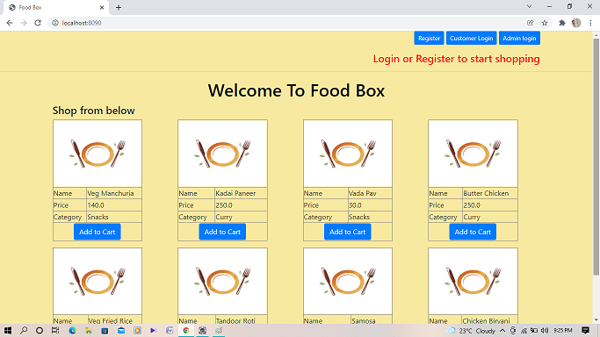

First we will look into Customer interactions:

# Customer Interaction:

Customers need to Login or Register into website to start shopping. If a customer clicks on Add Cart without doing that A prompt will appear until Login or Register.

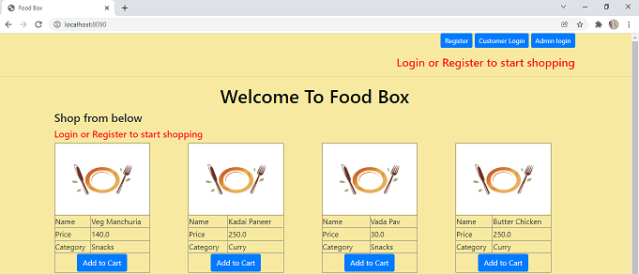

## **Customer Registration:**

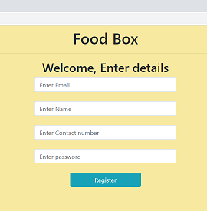

Customer need to enter email in the proper pattern. If not user will not be registered.

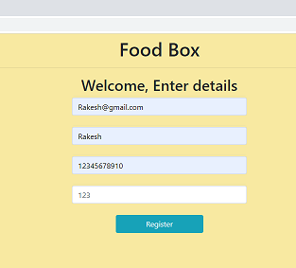

After Successful registration Customer will be logged in straight and ready for shopping

## **Customer Login:**

Login will also work in the same manner but user just need to enter credentials.

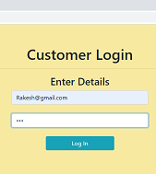Note: Login will work if user already registered previously.

## **Home Page After Login or Register:**

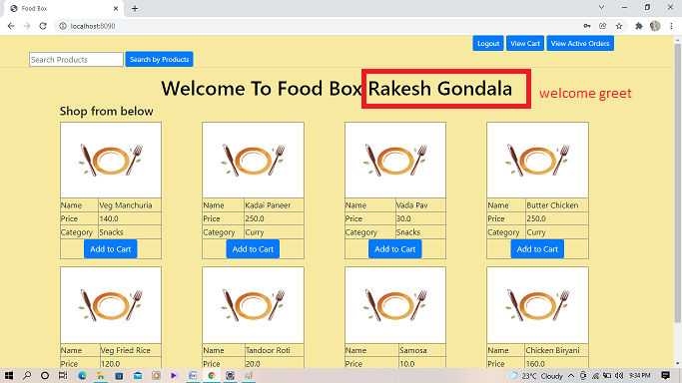

**Search Products:** Customer can Search products

**Logout**: Customer will be logged out and no longer can shop

**View Cart:** Items in cart for current session

**View Active Orders:** Previous active orders are shown by this button.

**Add to Cart:** Customers can add products to cart.

Customer clicks on view cart or View Active orders and If no items found in for the list.

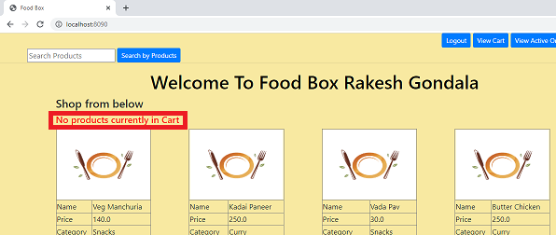

## **Search Products:**

User can enter any keyword as input to search products:

If any products were not found prompt is displayed showing “Products not found” else products are displayed and ready to shop.

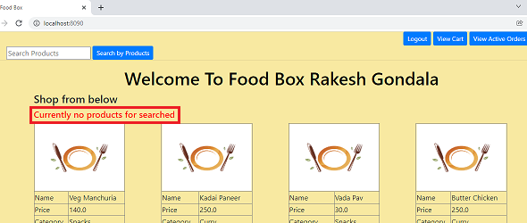

Imagine Customer searching for “snacks”. So all snacks will be displayed.

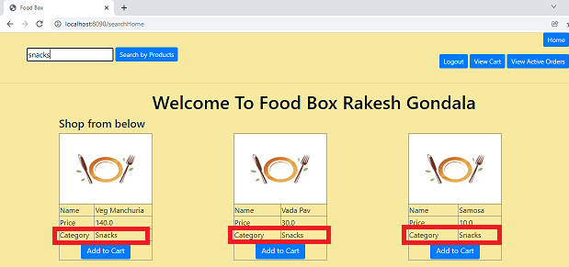Note: Now a Home button is displayed to go back to home with a full list of products.

## **Add Cart:**

If user clicks on Add to cart button. A new page is opened and customer needs enter quantity of food items

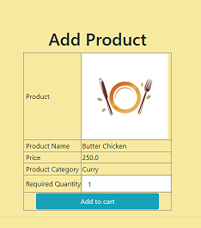

Now User needs to enter quantity then click on Add to Cart. then product is added to cart and redirected to homepage

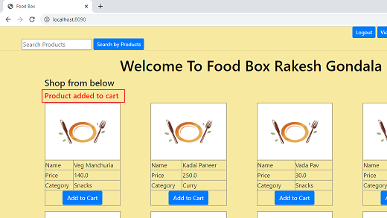

**Note:** until now products are added to cart only, Not yet bought.

Now Click on “View cart” to buy products.

**View Cart and Buy Products:**

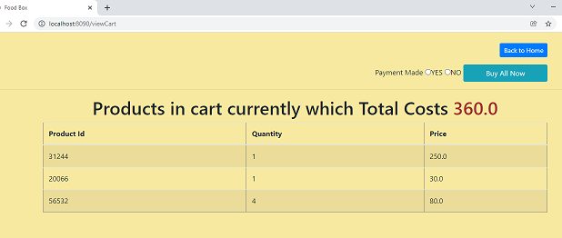

Here a dummy payment mode is added just to demo payment interaction. Customer needs click on “Yes” radio button to finish payment. If customer selects “No” or nothing then error is displayed.

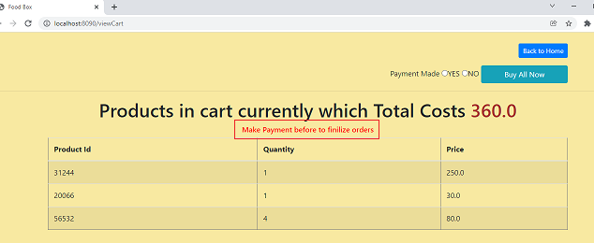

If customer selects on Yes and then click “Buy All Now”. Now products will be added to Purchase list

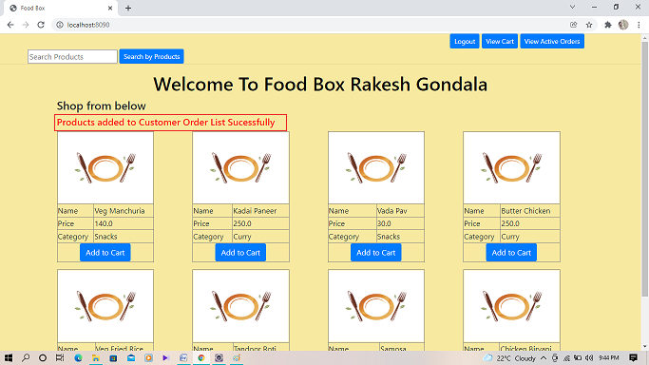

## **View Active Orders:**

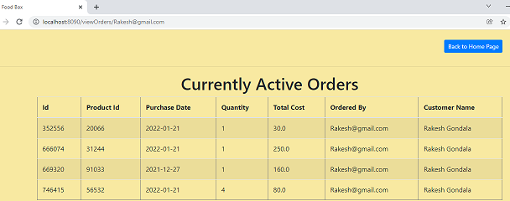

# Admin Login:

User needs to click on “Admin Login” button to redirect to login page.

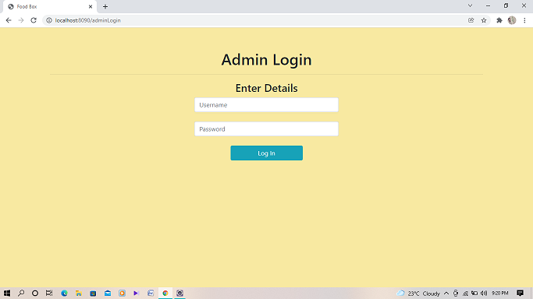

Admin needs to enter Username and password to login into portal.

If Admin enter username or password wrong Error message is displayed 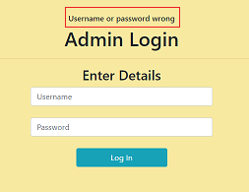

If Admin enters username and password correct then redirected to Admin Dashboard page.

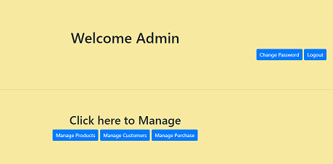

Operations in Admin Dashboard are:

* **Change Password:** to change admin password.
* **Log out:** Admin will be logged out.
* **Manage Products**: Add, Update and Delete Products.
* **Manage Customers:** View, Search and Delete Customers.
* **Manage Purchase:** View, Search and Delete Customers.

# 

# 

# Change Password:

Admin needs to enter old(existing) and new(fresh) password to change password.

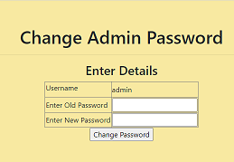

If Admin enter old password wrong. It shows error and change password is not success.

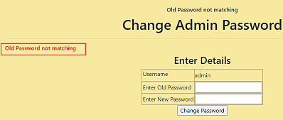

Password is changed only when user enter all fields correct.

# C:\Users\Rakesh\Desktop\Capstone Project\ScreenShots\Admin change passowrd2.png

# Manage Products:

## **C:\Users\Rakesh\Desktop\Capstone Project\ScreenShots\manage product1.png**

## **Add Products:**

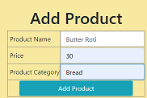

If user clicks on Add products after entering all fields product will be added.

## C:\Users\Rakesh\Desktop\Capstone Project\ScreenShots\manage product3.png **Update product:**

A new page will be opened to enter details.

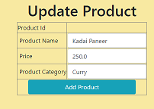

## **Delete Product:**

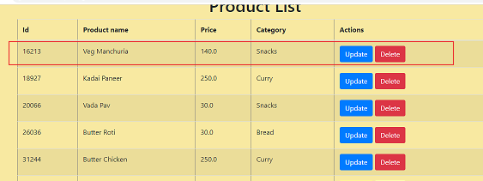

It will prompt a message ” Product Deleted Sucessfully”

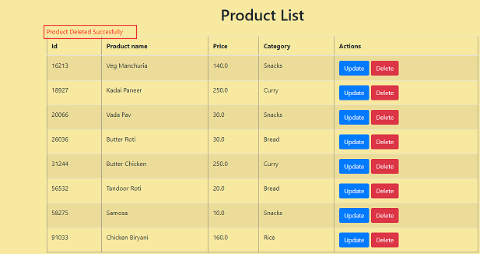

# Manage Customer:

Admin can manage Customers

## **Search Customer:**

Admin can enter any keyword to search, if nothing found prompt is displayed.

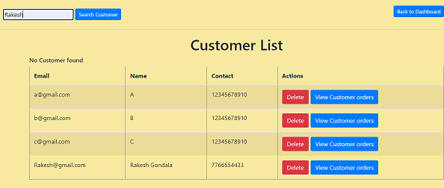

Assume Admin entered “Rakesh” and If customers found matching with keyword.

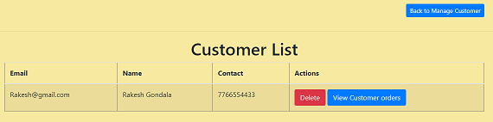**Manage Purchase:**

Admin can also Manage Purchases

## **Search Purchase By Data:**

Admin can select Date to search purchase on certain dates.

If no purchases or orders found error is displayed.

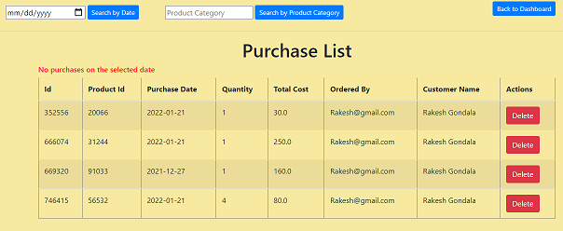

If any purchase found purchases or displayed.

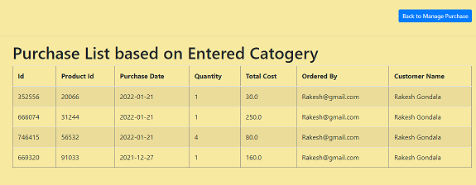`

# Conclusion:

By this I hope, I gave a presentation for all the operations. Code for application is given in links at the start of the documents. Execute for clear understanding.

**Thank You**